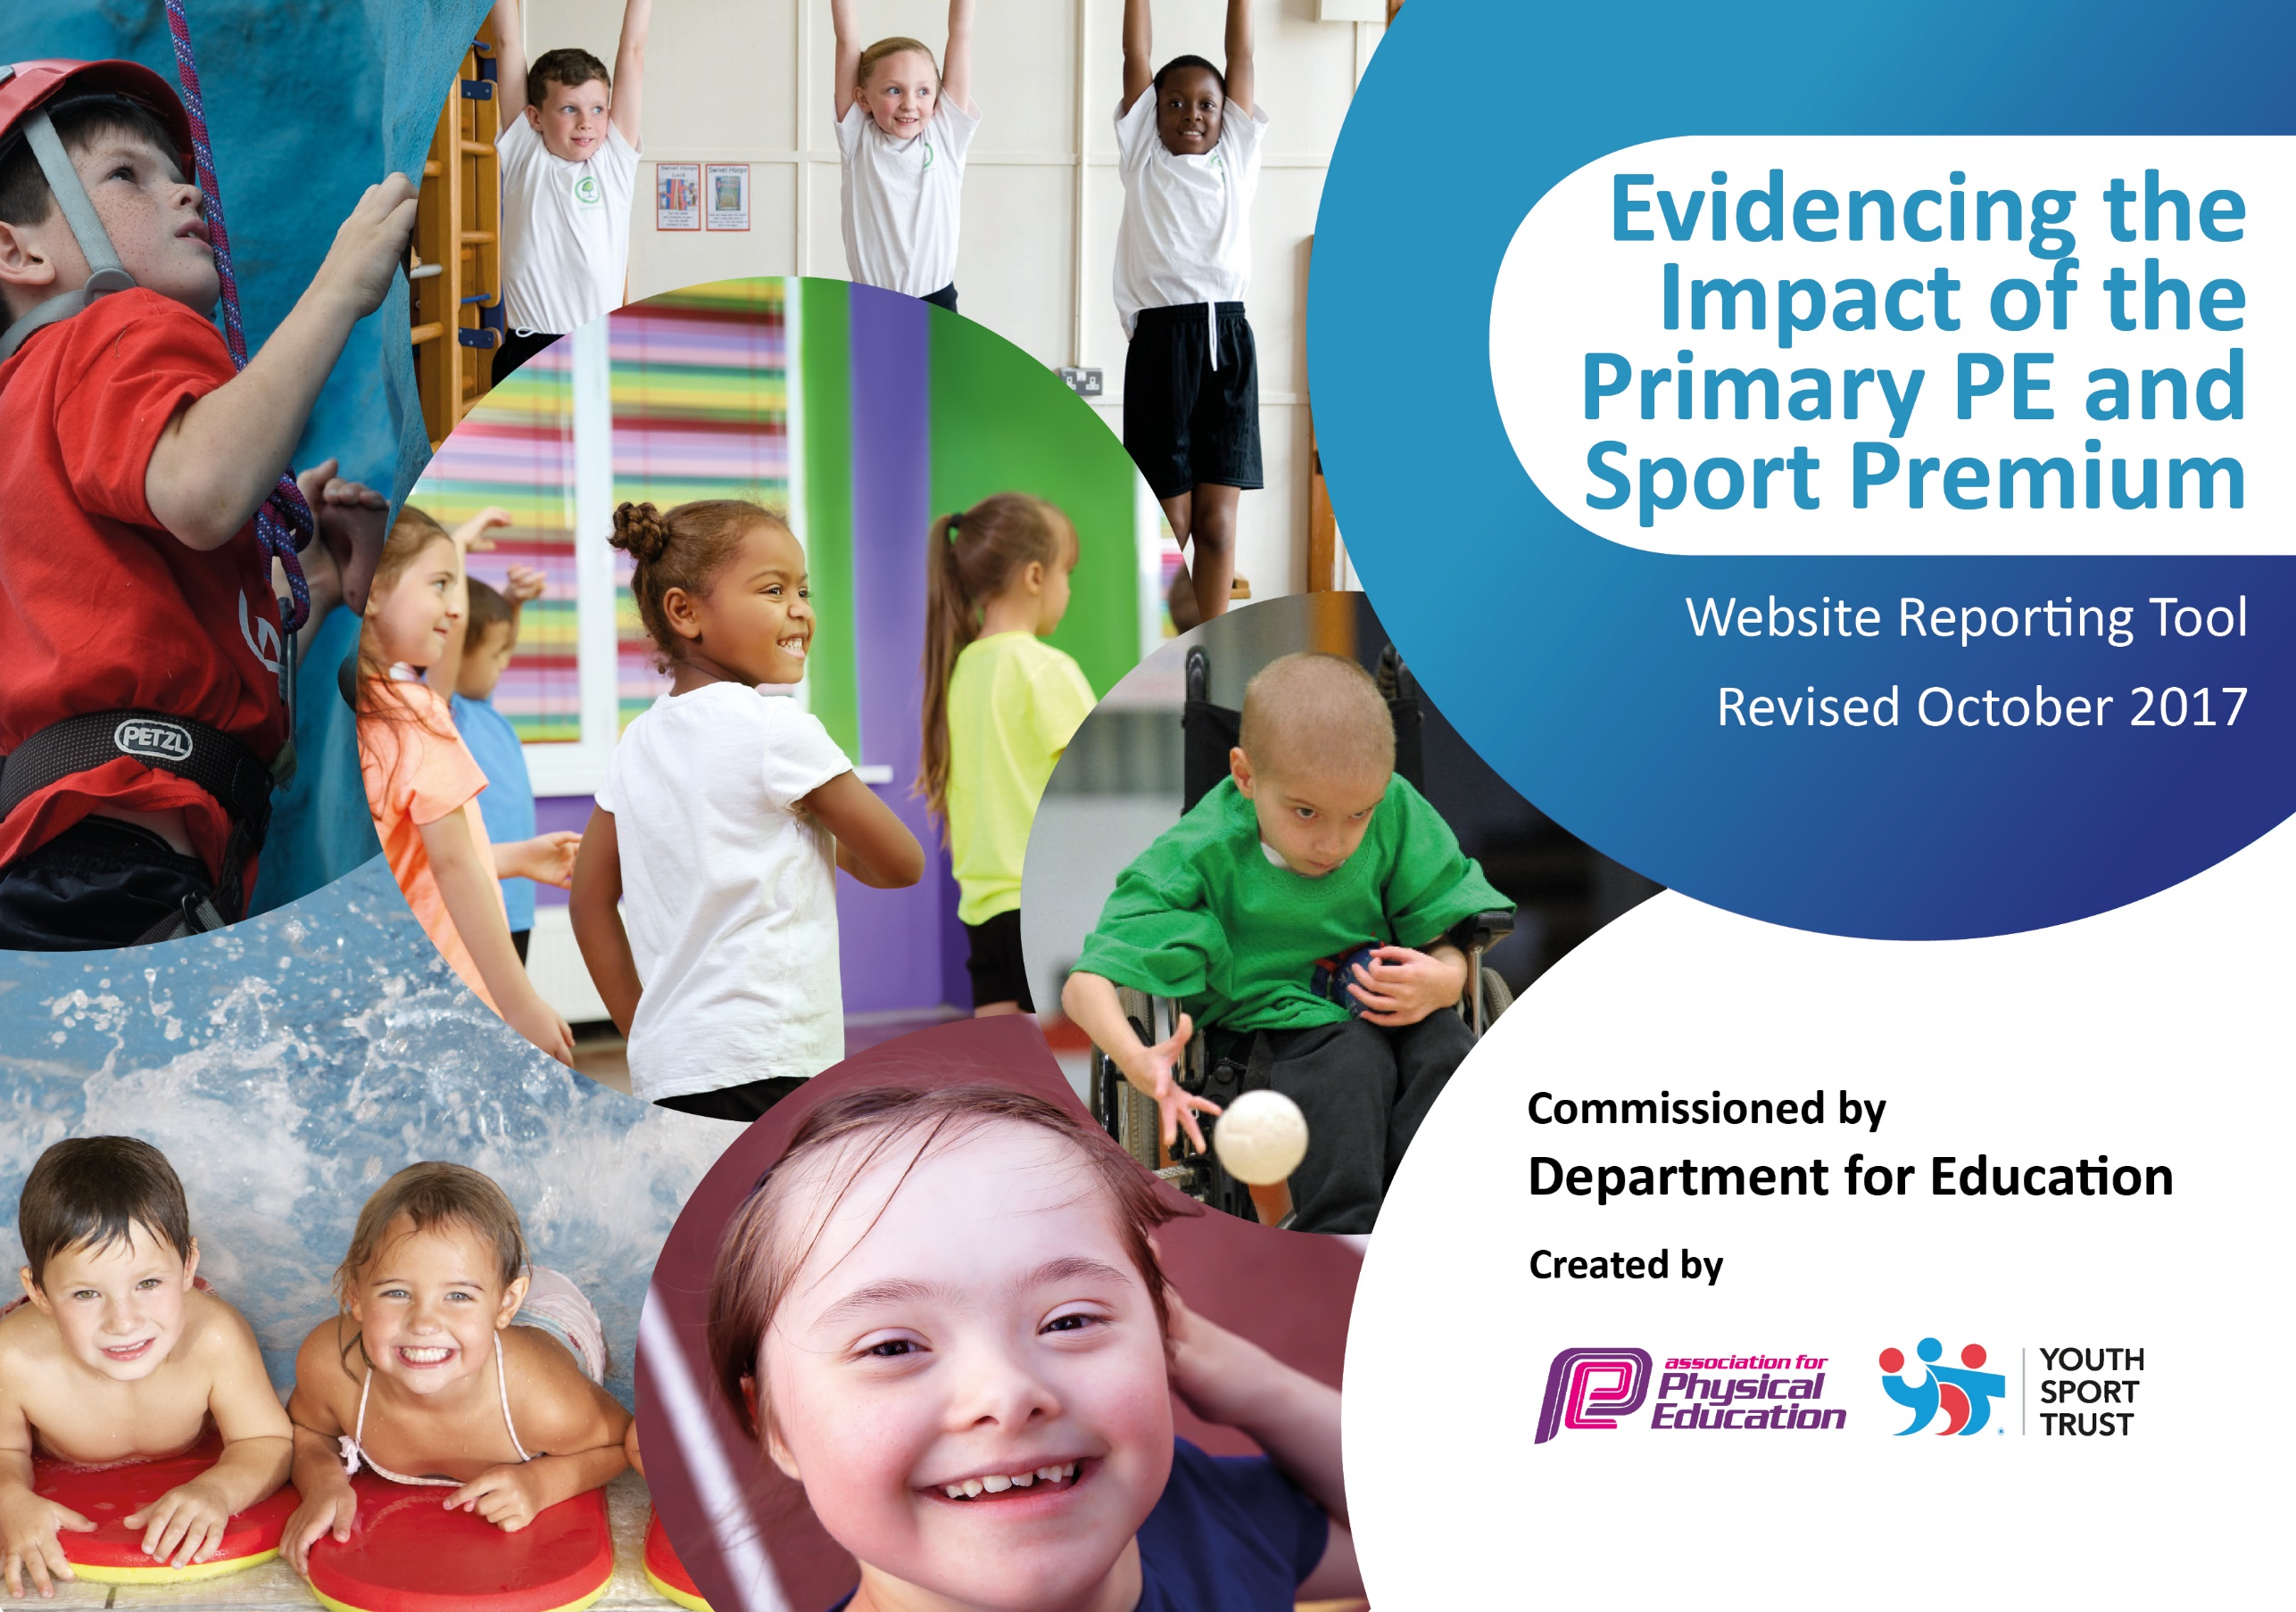

Schools must use the funding to make additional and sustainable improvements to the quality of PE and sport they offer. This means that you should use the Primary PE and Sport Premium to:

- develop or add to the PE and sport activities that your school already offers
- build capacity and capability within the school to ensure that improvements made now will benefit pupils joining the school in future years

Please visit gov.uk for the revised DfE guidance including the 5 key indicators across which schools should demonstrate an improvement. This document will help you to review your provision and to report your spend. DfE encourages schools to use this template as an effective way of meeting the reporting requirements of the Primary PE and Sport Premium.

We recommend you start by reflecting on the impact of current provision and reviewing the previous spend.
Under the Ofsted Schools Inspection Framework, inspectors will assess how effectively leaders use
the Primary PE and Sport Premium and measure its impact on outcomes for pupils, and how effectively governors hold them to account
for this.

Schools are required to publish details of how they spend this funding as well as on the impact it has on pupils’ PE
and sport participation and attainment.
We recommend regularly updating the table and
publishing it on your website as evidence
of your ongoing review into how you are using the money
to secure maximum, sustainable impact. To see an example of how to complete the table please click HERE.

Support for review and reflection - considering the 5 key indicators from DfE, what development needs are a priority for your setting and your students now and why? Use the space below to reflect on previous spend, identify current need and priorities for the future.

Key achievements to date: | Areas for further improvement and baseline evidence of need:
- Build upon CPD already taken place for staff to ensure highest quality outcomes for all children.

- Ensure all children have the opportunity to engage in 30 minutes a day healthy, physical activity in school.

- Further develop sports leaders in school.

Meeting national curriculum requirements for swimming and water safety | Please complete all of the below:
What percentage of your Year 6 pupils could swim competently, confidently and proficiently over a distance of at least 25 metres when they left your primary school at the end of last academic year? | 74%
What percentage of your Year 6 pupils could use a range of strokes effectively [for example, front crawl, backstroke and breaststroke] when they left your primary school at the end of last academic year? | 37%
What percentage of your Year 6 pupils could perform safe self-rescue in different water-based situations when they left your primary school at the end of last academic year?
Schools can choose to use the Primary PE and Sport Premium to provide additional provision for swimming but this must be for activity over and above the national curriculum requirements. Have you used it in this way? | Yes/No

Whole School Impact of the PE & Sport Premium Funding

Our PE and Sport Premium plans and key actions have become embedded within, inform, and support the achievement of our whole school Vision and Priorities identified within our Whole School Improvement Plan.

This ensures the most effective, sustainable use of the funding with PE and School Sport becoming a tool for whole school impact, outcomes and improvement.

Please now find below our Vision and key Priorities from our Whole School Improvement Plan (Autumn 2017- Summer 18). This is then followed by our PE and Sport Premium Action Plan (2017-18) with a column linking the two Plans together.

Sunnyside Primary Academy: School Improvement Plan (SIP) (2017-18)
Vision

That children learn actively in a caring, inclusive and stimulating environment, so that they are motivated to do their best and reach their potential. All children will leave the School having made at least good progress from their starting points in Reading, Writing, Maths and SPAG and will be confident, motivated, resilient and independent learners ready for their next stage of education.

To realise our Vision we have identified the following key priorities from our SIP:

Section 1: Effectiveness of Leadership and Management

Section 1 (1) To develop middle leaders.

Section 2: Quality of Teaching, Learning and Assessment

Section 2 (1) All teaching to be good or better.
Section 2 (2) To challenge more able pupils.

Action Plan and Budget Tracking
Capture your intended annual spend against the 5 key indicators. Clarify the success criteria and evidence of impact that you intend to measure to evaluate for students today and for the future.

Academic Year: 2017/18 |  | Total fund allocated: £18, 440 |  | Date Updated: 02/02/18
Key indicator 1: The engagement of all pupils in regular physical activity – Chief Medical Officer guidelines recommend that primary school children undertake at least 30 minutes of physical activity a day in school |  |  |  |  |  | Percentage of total allocation:
 |  |  |  |  |  | %
School focus with clarity on intended impact on pupils: | Link to Priorities  in School Improvement Plan |  | Actions to achieve: | Funding allocated: | Evidence and impact: | Sustainability and suggested next steps:
- Develop a Healthy Active Engagement Programme to encourage more children to engage more regularly in additional physical activity opportunities |  |  | All children to have 2 hours of PE a week.  5 a day fitness programme to be sustained. This will allow children to participate in short dance activities lasting for 5 minutes in a fun way. To begin to use Go Noodle.  Extra-curricular activities  A range of clubs to be offered to all children from YR-Y6 within school to encourage them to be physically active before and after school which will change/added to on a termly basis;  As of Spring Term our clubs and providers are:  - Hotshots Basketball (Y3-Y6)  - GLK-Football & Gymnastics(Reception-Y6)  - Brawny’s Fitness Bootcamp (Y3-Y6)  - Premier Sports-Street Dance (Reception-Y6)  Teacher led sports clubs-Cross country, hockey, strictly dancing and indoor athletics (spring 2)  Active playgrounds  Lunchtime supervisors will undertake training on 13.03.18 based on active to playgrounds. This is to ensure that playtimes are active and encourage children to be physically active during their breaks. Children will be encouraged to be resilient, persevere, motivated and determined as well as developing their communication, team work and good sportsmanship.  Swimming  The academy is going to use a proportion of funding to ensure all children in Year 6 are able to access a top up swimming programme. Furthermore, the academy will identify children in other year groups who require additional support in order to achieve end of KS2 swimming objectives. As the academy views swimming as a fundamental life skill and also recognizes the need for children to develop water confidence and safety.  Playground markings  To buy and develop the use of agility playground markings to increase the number of children being physically active during break and lunchtimes. | (Sports premium used to subsidise fitness bootcamp)  £2, 000  £4, 000-£5, 000 | Whole school PE timetable.  - Scheme is already in place.  - All teachers to be issued logins-old and new staff to ensure maximised use.  - Introduce staff to Go Noodle.  - Clubs registers.  - Competition registers.  - 150% increase in number of children participating in fitness bootcamp since September to February 2018.  - 100% in number of children participating in cross country (teacher led) since January to February 2018.  - Lunchtime staff will be trained to motivate and encourage children to be active during their break. Increased number of children participating in games/activities led by lunchtime staff and leaders.  - Increased number of children to be able to swim 25m-list to be kept on assessment tracker.  - Children will take ownership of being physically active during break and lunchtimes and leaders will be able to use trails to support younger children to be active. The trails can be used as a warm up to PE lessons.
Key indicator 2: The profile of PE and sport being raised across the school as a tool for whole school improvement |  |  |  |  |  | Percentage of total allocation:
 |  |  |  |  |  | %
School focus with clarity on intended impact on pupils: | Link to Priorities  in School Improvement Plan |  | Actions to achieve: | Funding allocated: | Evidence and impact: | Sustainability and suggested next steps:
- Support the development of the whole child through the achievement of whole school outcomes as a result of a focus on PE, School Sport and Physical Activity |  |  | Children will have access to a wide range of clubs before and after school to participate in.  5 a day fitness programme to be sustained. This will allow children to participate in short dance activities lasting for 5 minutes in a fun way.  Intra and inter school competitions  Building staff confidence through CPD by teaching alongside an experienced sports coach.  Children will have access to a wide range of clubs before and after school to participate in.  Friday 9th February 2018-Whole school well-being day. Children to engage in a range of activities to promote their health and well-being. |  | - Clubs registers and timetables  - Photos  - Photos of competitions  - Discussions with staff and children  - Photos and child’s voice  - Children will be more aware of the importance of a healthy but active lifestyle to promote their well-being.

Key indicator 3: Increased confidence, knowledge and skills of all staff in teaching PE and sport |  |  |  |  | Percentage of total allocation:
 |  |  |  |  | %
School focus with clarity on intended impact on pupils: | Link to Priorities  in School Improvement Plan | Actions to achieve: | Funding  allocated: | Evidence and impact: | Sustainability and suggested next steps:
- Improve the progress and achievement of all children by increasing staff knowledge, skills, understanding and confidence to deliver outstanding PE, School Sport and Physical Activity |  | Staff CPD programmes  - Teachers to have CPD in based on Gymnastics in Autumn Term (KS2) and Spring Term (KS1) with the support of an experienced coach from Allison Consultancy.  - PE leader to attend three central training days with GDFT and disseminate information back to staff.  - Staff to have 5 hours training with Allison Consultancy.  - Distribute staff handbook/policy to ensure staff/new staff are aware of practises related to PE.  - Assessment tool to be provided by GDFT to be continued to be used for assessment in PE.  - Access to Youth Sports Trust and Sport Plan for creative ideas, plans and activities.  - Develop and update school scheme of work to support teachers with planning and delivering skills in PE with confidence. | £5,000  £1, 400  £1, 000 | Discussions with staff  Staff audit  Staff to input data on a termly basis  New scheme of work to be put into place.
Key indicator 4: Broader experience of a range of sports and activities offered to all pupils |  |  |  |  | Percentage of total allocation:
 |  |  |  |  | %
School focus with clarity on intended impact on pupils: | Link to Priorities  in School Improvement Plan | Actions to achieve: | Funding  allocated: | Evidence and impact: | Sustainability and suggested next steps:
- Increase the range of activity opportunity outside the curriculum in order to get more pupils involved. |  | - Maintaining and purchasing further sports equipment (if required) to provide a wider range of sporting activities or to support intra or inter school competitions.  - Continue to implement a curriculum that is broad and balanced including traditional and non-traditional sports.  - Access to a wide range of clubs before and after school to participate in including traditional and non-traditional sports. | £1, 000 | Equipment audit  PE Long term plan  Clubs registers
Key indicator 5: Increased participation in competitive sport |  |  |  |  | Percentage of total allocation:
 |  |  |  |  | %
School focus with clarity on intended impact on pupils: | Link to Priorities  in School Improvement Plan | Actions to achieve: | Funding  allocated: | Evidence and impact: | Sustainability and suggested next steps:
- To introduce additional, inclusive competitive sports opportunities providing the opportunity for all children to participate. |  | Whole school intra-school competitions organised with the support of Leaders and House Captains.  Whole School Sports Day  Organise and take part in a range of inter school competitions:  - GDFT competitions-Primary Sportshall Athletics for 30 Year 5 and 6 pupils.  - NSSP competitions-11 different sports competitions signed up throughout the year.  - Kings for gold-Kingsthorpe cluster competition for 28 competitors across YR to Y6.  - Regional Dance Festival in Spring Term. | £2, 000 | - Leaders and house captains to discuss ideas for intra-school competitions  - Competition list and registers  - Photographs  - Sports display of physical activity and health  - Socialisation with other children from other schools / backgrounds  - Experience of the feeling of achieving their best  Experience of gaining awards and certificates and the feelings of achievement
Additional Outcomes and benefits of the funding |  |  |  |  | Percentage of total allocation:
 |  |  |  |  | %
School focus with clarity on intended impact on pupils: | Link to Priorities  in School Improvement Plan | Actions to achieve: | Funding  allocated: | Evidence and impact: | Sustainability and suggested next steps:
- Raise awareness of the benefits of PE & Sports Premium funding and increased opportunities for children |  | Build upon the training and use of the Allison Consultancy PE MAPs Assessment Pack  - Identify and establish baseline of whole school progress and attainment against National Curriculum PE Age Related Expectations in the Autumn Term.  - Continue to measure progress and attainment in Spring and Summer Term.  - Use this to assess future progress and attainment.  Website  - Regularly update the sports premium section of the website including competitions, achievements and participation. To also display this within school on the central PE display board. | Internal Budget | - Assessment system implemented  - Progress and attainment data collated  - Planning includes reference to the PE MAPs  - Sports Premium section of the website  Sports display in main reception to be regularly updated with photos, clubs and competitions. This is develop a sense of teamwork, sportsmanship and achievement across school.

